Ph sensor :

Uart to i2c : (green to blue)

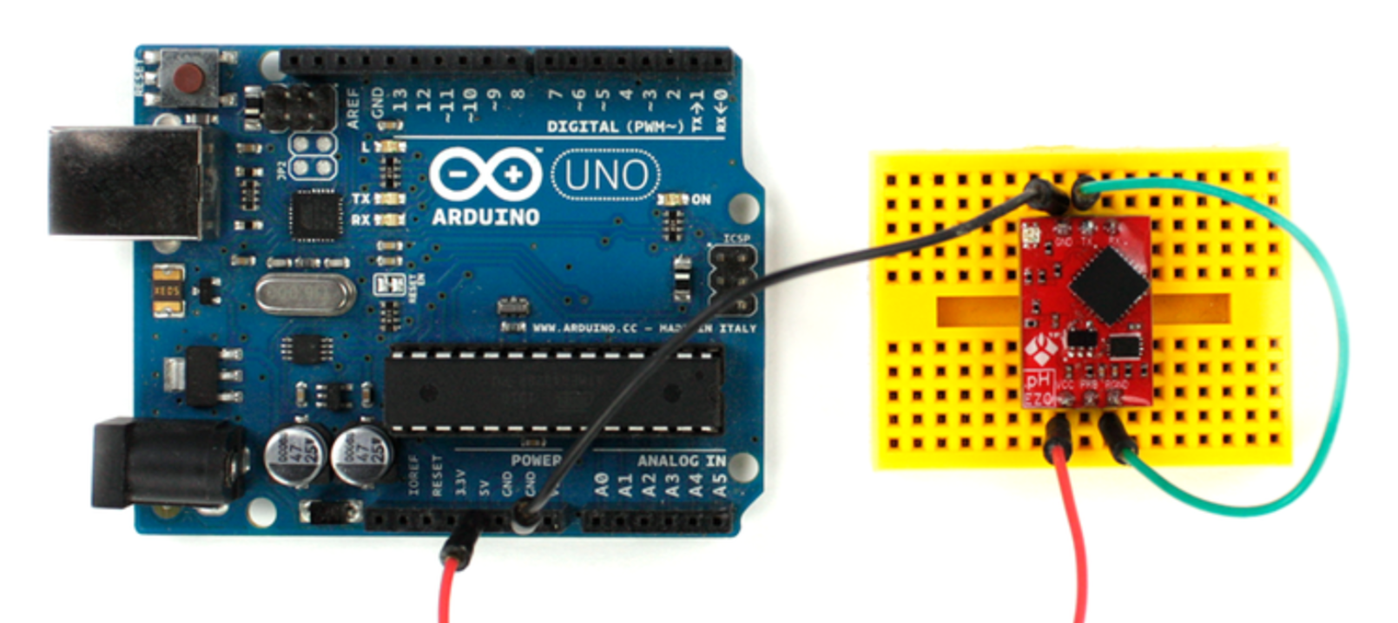

Now the devics is in i2c mode :

Connect the sensor on the isolated carrier board:

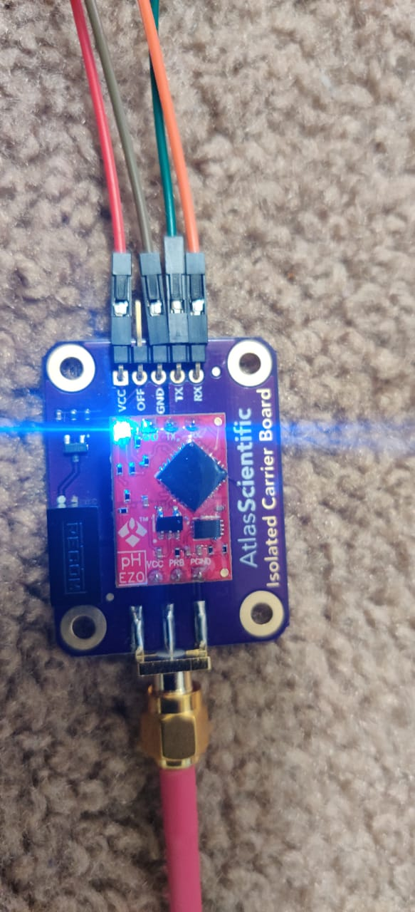

Now connect the

Once you switch to I2C mode, RX and TX become SCL and SDA  
RX=SCL=pin5  
TX=SDA=pin3

Vcc to 5v

Gnd to gnd of pi

Enter command in cmd:

cd ~/Raspberry-Pi-sample-code

sudo python i2c.py

poll (for continous reading)

r for single reading

\*\*\*\*\*\*\*\*\*WE HAVE 5 SENSORS \*\*\*\*\*

RTD,PH,ORP,DO,EC